

CIVE202 – Drinking Water Project #2 Technical and Nontechnical Executive Summary’s

Brock Hoover, Fatima Davila, Mehgan Paulino, Owen Betts

May 1, 2026

Distribution of all States Total TLC Violations by Year
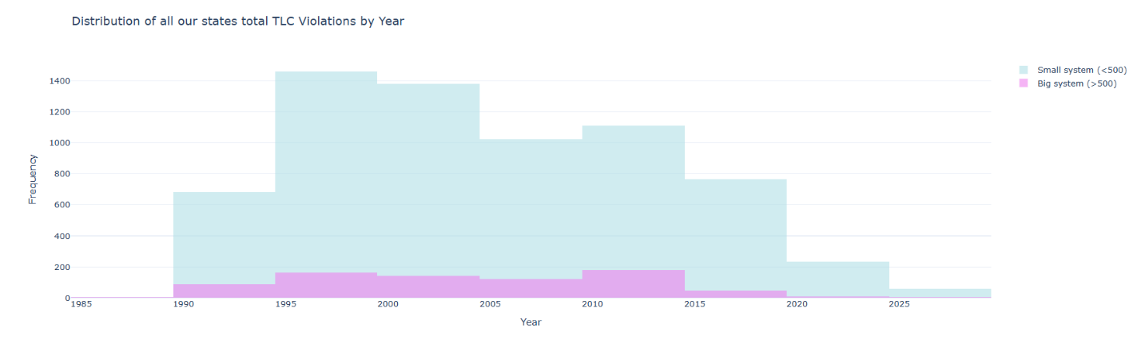
Figure 1, Distribution of Total Coliform Rule (TCR) violations over time, comparing small (<500 connections) and large (>500 connections) water systems across selected states.

Technical Executive Summary
This analysis evaluates Total Coliform Rule (TCR) violations across multiple states using SDWIS data, with a focus on differences between small (<500 connections) and large (>500 connections) water systems. The distribution of violations over time indicates that small systems consistently account for most reported violations, with notably higher frequencies between approximately 1995 and 2015. In contrast, large systems exhibit substantially lower violation counts across all years, with only minor fluctuations. Both system types show a general decline in violations in more recent years, which may reflect regulatory improvements, enhanced monitoring practices, or infrastructure upgrades. The disparity between system sizes suggests that smaller systems may face greater challenges related to operational capacity, funding, or compliance management. These findings support further investigation into structural and resource-based limitations impacting small system performance.

Non-Technical Executive Summary
This study looks at drinking water safety by examining how often water systems violate health standards over time. The chart shows that smaller water systems tend to have more violations compared to larger systems, especially between the late 1990s and early 2010s. Larger systems generally have fewer issues and remain more consistent over time. Encouragingly, both small and large systems show a decrease in violations in recent years, which could mean improvements in water treatment and regulation. However, the higher number of violations in smaller systems suggests they may need additional support or resources to maintain safe drinking water. Overall, the results highlight the importance of continued investment in water system infrastructure, especially for smaller communities.

